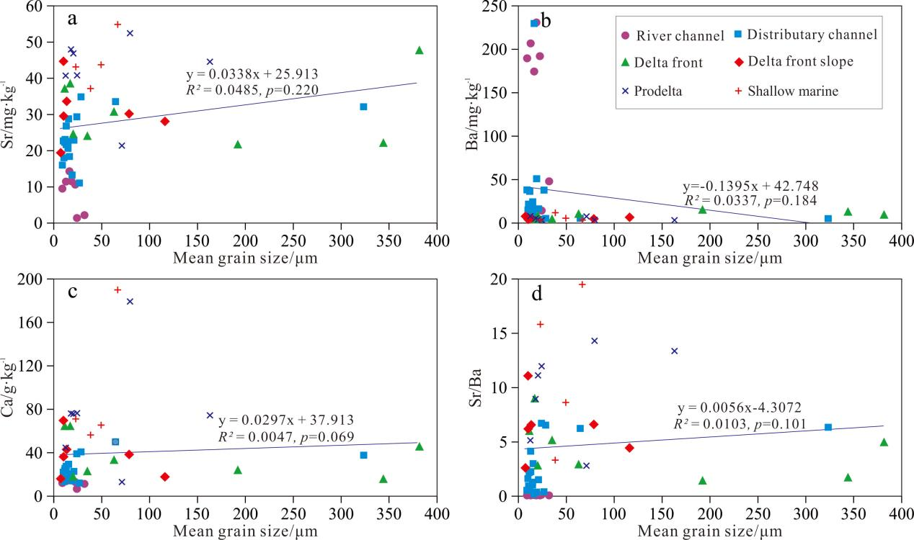

　Fig. S1. Correlation between alkaline earth metals and mean grain size of surface sediments in the Jiulong River mouth.